1. Output where all processes eventually gain access to the file.

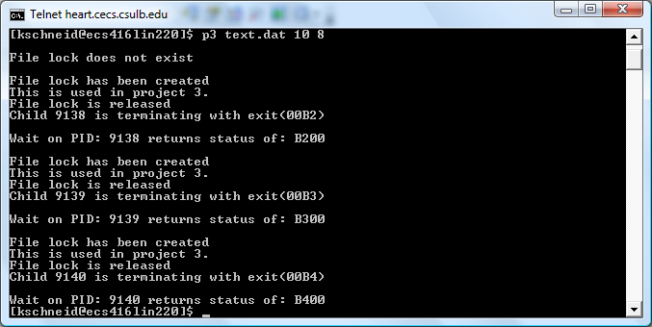

1. Output where at least one process fails and displays “Unable to obtain lock file.”

